User 's manual
Amoi E730 Voice/Video recorder

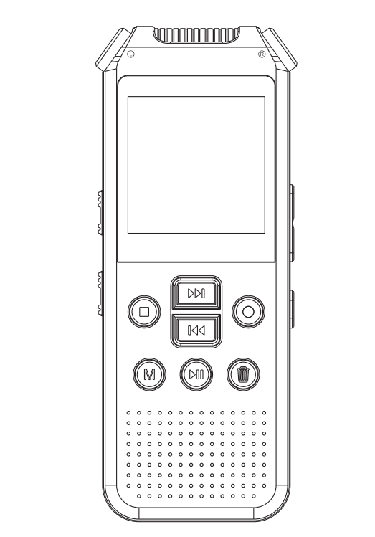

Preface
Thank you for choosing the Amoi E730 voice/video recorder!
In order to help you operate this product as quickly as possible, we have a comprehensive user manual include product description, how to use it. please carefully read all the information we have provided so that you can make better use of the product.
At the time of writing this manual, we are very serious and strict, we hope to provide you with complete and reliable information, but inevitably have errors and omissions, please give your understanding and sincerely welcome your criticism and correction. If you found any problem, please call our service hot line, thank you for your support and cooperation!
We are not responsible for the loss or damage of personal data caused by software, hardware misoperation, product maintenance, battery replacement or other unexpected circumstances. We are not responsible for any other indirect losses caused by this. Please back up your data to desktop (notebook) computer in time. And we can not control lost caused by the user's misunderstanding of this manual, so we will not be liable for any unintentional damages that may occur during the use of this manual and are not responsible for any third party claims arising out of the use of the product.
● The information in this manual is subject to change without notice.
● The information in this manual is copyrighted, and any part of it is not subject to the prior agreement of the Company
Written permission is not allowed in any way photocopying and reproduction.
● The Amoi Company reserves the right of final interpretation of this manual, Three Guarantees certificate and related materials.
Enterprise implementation of standards: Q / BATB003-2013 corporate standards for the record: 20131016

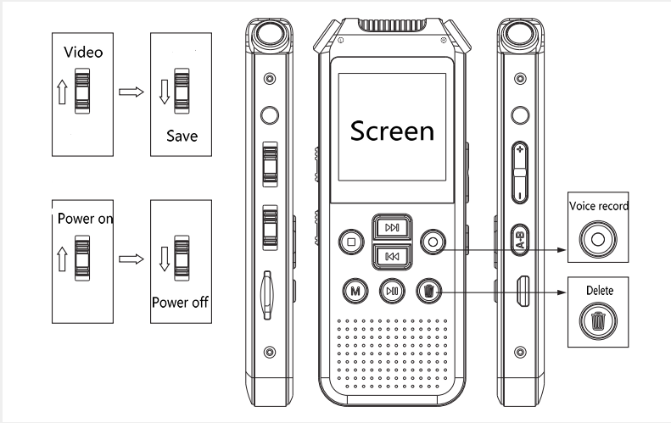
- Power on/off
- Power on：Please slide up the power key to “On”position and then press key for 3 seconds the device will starting up.
- Power off: when the device is working, long presskey till the screen show“Byebye”
- Start Record/Save
- Video recording：In working state slide up the video key to " Video " position to start recording video.
- Save video: In video mode slide down the “Video”key to “Save” position for save current videos.
- Turn on the screen saver: In video mode press the “M” turn on the screen saver.
- Turn off the screen saver: In screen saver mode press the “M” turn off the screen saver.
- Recording Voice: In working state press the “Voice record” button start record the voice.
- Save the audio files: In Recording mode press back buttonsaving the audio files.
- Take a picture：In a power-on state from main menu press select the “Camera”, press “M”open camera, press for take a picture.
- Playback
- Video playback: In the main menu direct to recorded video files, press “M”enter to video list,press key for select and key start play.
- Audio playback：In the main menu direct to Recorded Audio files, press “M”enter to audio list,press key for select and key start play.
- Play music：In the main menu direct to Music files, press “M”enter to music list,press key for select and key start play.
- Driving Recorder setting
In the main menu direct to system setting→Video record mode→Carcoder mode press key confirm selection and then key for back to main menu.
Now please slide up the video switch start the Driving Recorder.
Attention: The device will separate the video files every 3 minutes to save automatically, the last one will cover the beginning one after 50 files or the memory card full store. Please backup the video within 150 minutes so as not to lost.
- Camera auto detect
In the main menu direct to system setting→Camera auto detect press key for select and key confirm your selection. and then key for back to main menu.
Now please slide up the video switch start the camera auto detect Record.
If no any moving object after 30 seconds the device will sleep, and when the object moving before the camera been detected the device will wake up automatically and start to record it.
- Key lock/Child lock setting
Turn On/off the lock：Long press the A-B In the recording, music, main menu interface the screen display Keyboard locked, all the key been locked now. Long press A-B again for unlock.
- TF memory card
Insert the TF memory card to TF slot the screen will display SD card install success.

Attention:
- Please do not format the device from PC to avoid recording adverse effect.
- Please slide down the power key to turn off the device if you are not use it for a long time.
- Please do not use the device in particularly hot, cold, dusty or humid environments.
- Do not drop down during using.
- If the battery indicator is emptythe device will turn off automatically, please charging for it in time.

Declaration：
※ Please pay attention to the backup your data in a time, we do not responsible for data lost due to the incorrect operation.
,※ Our company reserves the right to improve the products, Any product specifications and design change without prior notice.please understand it.
※ Pictures and descriptions listed in the manual are for reference only, please to prevail in kind or real products.
※ This machine is not waterproof, do not splash or pour water on.
Ⅱ. Features:
- New generation digital voice/video recorder
- High resolution 1.5 inch TFT display
- Zinc Alloy die-casting molding shell,durable and anti - extrusion.
- Videos, photo shoots, recording time settings
- Video footage show the time, date
- Video files folder stored by date separately
- AVI Format resolution 1280*720 & 640*480 optional
- Native video playback directly
- Audio, video files delete on the device directly
- High quality record the voice
- A-B Repeat
- Built in Hi-Fi speaker
- Built in High definition Camera
- Support TF extend the memory
- Support phone recording
- Car Video Recorder
- Camera auto detect
- Built-in Lithium Battery

Ⅲ. Product graphic
- Earphones socket
- Video/Save
- Power on/off
- USB port
- TF slot
- Built in left channel microphone
- Built in right channel microphone
- Screen
- Previous/ fast reverse
- Menu/OK
- Next/Fast Forward
- Stop/Back
- Audio record
- Play/Pause
- Delete
- High - Fidelity Speaker
- External microphone input / phone recording / external audio source input
- Volume up
- Volume down
- Key lock/A-B repeat
- Camera
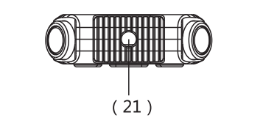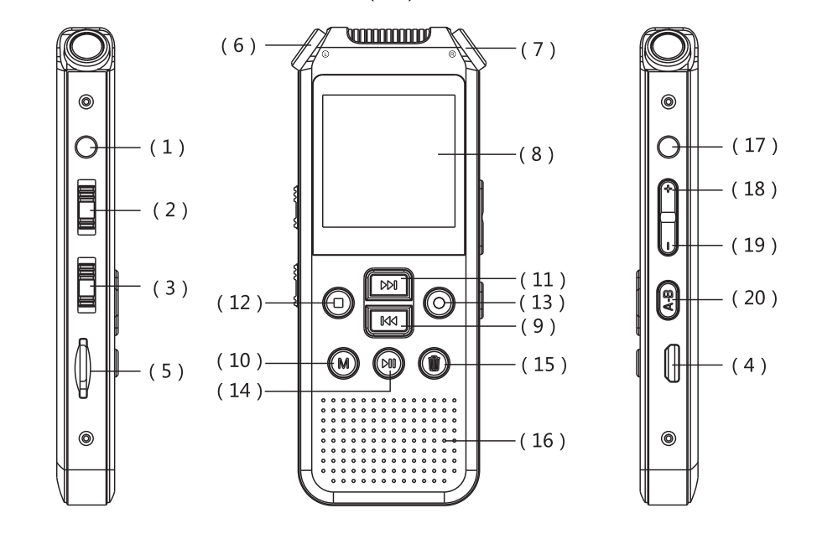
Ⅳ.Main Function
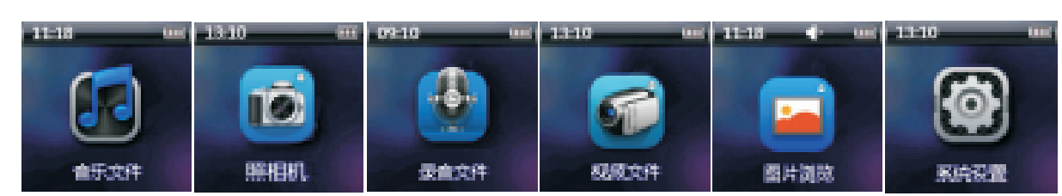
Music Camera Audio files Video files Picture System set
5.1 Language setting
After power on please pressdirect to system setting, press“M”enter to select the first line”语言选择”，“M”key for enter the next menu and then pressmove cursor to “English”and key confirm your selection.
- Connect to PC
Please plug one end of USB cable into the computer USB port and the other end into the USB port of this device.
Please use the normal method to remove the disk to prevent data lost.
- Charging
Plug one end of USB cable into the USB port of your PC and the other end into the recorder USB interface, the charge generally 4 hours or so will be full, battery icon shows the full mark .
This device not attach the adapter, if you charge for it with adapter please plug one end of USB cable in to USB port of adapter and the other end into the recorder USB interface, the output of adapter recommend 5V/500mA-1A.
※The output over 5V maybe cause the damage, please note it!
Attention：This machine has automatic save power function, if no operate over 3 minutes in stop status the machine will automatically shutdown.
Please copy MP3 music files to the removable disk " AUDIO " folder. The device will UNRECOGNIZE the files if you put it to other place.

Technical specifications
Dimension | 95x36x11MM
Screen | 128*128 1.5 inch TFT Screen
USB interface | USB2.0 High speed
Storage | TF（Max 64G）
Battery | 3.7V/600MA Polymer lithium battery
Battery life | Video | 480P around 5 hours  720P around 3 hours
 | Audio | Around 24 hours（Full charged, earphones, screen saver play ）  Continuous recording around 8 hours
Video format | AVI | 1280*720 640*480 optional
Audio format | MP3 | 8KHz-48KHz 8KHz-768KHz
 | WMA | 32KHz-48KHz 48KHz-192KHz
Audio record | LQ | 256kbps
 | MQ | 384kbps
 | HQ | 768kbps
8GB | Audio | HQ 22 hours，MQ 44 hours, LQ 66 hours
 | Video | 480P： statics 4 hours，dynamic 3 hours  720P： statics 2 hours，dynamic 1.5 hours
16GB | Audio | HQ 44 hours，MQ 88 hours, LQ 132 hours
 | Video | 480P： statics 8 hours，dynamic 6 hours  720P： statics 4 hours，dynamic 2.5 hours
Earphones | Maximum output | 10mW+10mW (32Ohm)
 | Frequency | 20Hz-20KHz
 | Signal-noise ratio | ＞70db
 | Degree of distortion | 0.05%
Operating temperature | -5~40℃
Support system | Windows 98 Second Edition/Millennium Edition/2000/XP/Windows 7/Windows 8/Windows10/Mac OS

